3/5/2018

Nekhel Das, Qin He

Methods In physics

Project 3

The Compton scattering

1. Introduction: 2
2. Theoretical Background on Compton Scattering 2

Derivation of Compton wavelength and energy equations 2

1. Distribution functions 6

Normal Distribution or Gaussian distribution 6

Cauchy Distribution or Lorentzian distribution 6

Normal Distribution vs Cauchy distribution 7

1. Procedure and Experimental system 8

Experimental Apparatus 8

Operating principle 9

Effects of energy spectrum collection time in result 9

Energy calibration 9

1. References 10

# Introduction:

E=hv was one of the successful theory in 20th century which is emission or absorption of discreate quanta energy. It was also shows huge impact on photoelectric effect explanation/ In 1920 an American physicist named Arthur H. Compton decided to search an answer of other phenomena which failed by classical physics. In experiment on monochromatic X-rays scattered from materials decrease their energy(frequency) after the interaction or scattering. Classical electromagnetic theory could not explain this phenomenon because frequency is a property of electromagnetic wave and cannot alter its direction by scattering. But in other hand we can explain this phenomena by considering the light as photon which elastic collisions with the electrons in the materials. Later in 1923 a complete experimental result compared with the predictions from the quantum theory of light, gives the science an impressive theory. In this experiment we are going to study this theory by the angular energy dependence of gamma rays scattered by electrons in targets (aluminum). He won Nobel prize in Physics for this in 1927. [1]

## Theoretical Background on Compton Scattering

Compton scattering is a collision between a photon and loosely bound outer-shell orbital electron of an atom. Interaction looks like a collision between the photon and a free electron because of the incident photon energy more than the binding energy of the electron of the atom. This photon does not disappear but in deflected through a scattering angle theta. The energy is transfer in recoil electron thus photon loses energy in the process. In our experiment photon comes from gamma rays from americium radioactive source. Aluminum plate use as scatter object because of its higher density of free electrons. [2]

## Derivation of Compton wavelength and energy equations

Review Compton’s relativistic theory and derive the equation (1) presented in the handout for the change of wavelength in Compton scattering. Derive equations for the energy of a scattered photon and the scattering electron’s kinetic energy as a function of the energy of the incident photon and the angle of scattering. Draw a

picture of the energies as a function of the angle of scattering. Use the most probably gamma energy of the 241Am sample as the energy of the incident photon.

According to conservation of momentum,

$p1 = p2 +{ p}_{e}$ (1)

where p1 and p2 are initial and final momentum of photons, respectively, pe is momentum of the recoiled

electron (of course, electron has no momentum initially at rest).

Conservation of energy simply states:

$${ E}_{1} + E_{e1} = E_{2} + E_{e2} (2)$$

where E1 and E2 are initial and final photon energies, and Ee1 and Ee2 those of the electron.

In relativistic condition, photon energies can be written straightforwardly, by Ei = pic = hc/ʎi, and initial

energy of the electron is its rest mass energy; therefore, Ee1 = mec2. Final energy of the recoiled electron

now must include the momentum pe and is written: $E_{e2}=\sqrt{{p_{e}}^{2}c^{2 }+ {m_{e}}^{2}c^{4}}$. Now we can substitute the

energies and rewrite Eq. 2 to be

$p_{1}c + m_{e}c^{2} =\sqrt{{p_{e}}^{2}c^{2 }+ {m_{e}}^{2}c^{4}}$ (3)

Let us collect like terms by rearranging:

Pe2c2 + me2c4 =(p1 -p2)c + mec2

(4)

We can also solve for ${p_{e}}^{2}$ from Eq. 1:

${ p}_{e}= p1 - p2$

${ p_{e}}^{2}{{{=p}_{1}}^{2}+ p_{2}}^{2}-2p_{1}p_{2}cosƟ$ (5)

Equating the right sides of Eq4 and 5, we end up with:

$${{p_{1}}^{2}+ p_{2}}^{2}-2p_{1}p_{2}+2{(p}_{1}- p_{2})m_{e}c{{{=p}_{1}}^{2}+ p_{2}}^{2}-2p_{1}p_{2}cosƟ$$

$${(p}_{1}- p_{2})m_{e}c=p_{1}p_{2}(1-cosƟ)$$

$$(\frac{h}{λ_{1}}- \frac{h}{λ_{2}})m_{e}c=\frac{h^{2}}{λ_{1}λ_{2}}(1-cosƟ)$$

$$λ_{2}-λ_{1}=\frac{h}{m_{e}c}(1-cosƟ)$$

For energy $$E^{'}=\frac{E}{1+(1-cosƟ)\frac{E}{m_{e}c^{2}}} (6)$$

Where $E = h\frac{c}{λ_{c}}$, $1.9199 rad=<Ɵ≤2.6099 rad$

[3]

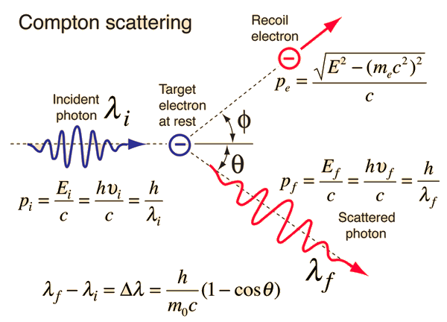

Figure 1: Compton scattering diagram before and after the collision between gamma ray with electron. [4]

From equation (6), we see that the energy of scattered photon lies in the range of maximum value when cos is -1 and minimum value when cos is 1. So, we can expect that our experimental result would give us the energy of scattered photon in this range.

$$({E'}_{max},{E'}_{min})= (E,\frac{E}{\frac{2E}{{mc}^{2}}+1}) (7)$$

We can also find an expression for kinetic energy of a scattered electron and scattered energy of the gamma ray.

Kinetic energy of an electron is given by,

$$E_{k}=E_{e}-E_{0}=E-E' (8)$$

Substituting equation (6) in (8), we get

$$E_{k}=\frac{E}{\frac{E_{0}}{E(1-cosƟ)}+1}$$

where, E0 is the rest mass energy of the electron. This equation explicitly shows the dependency of kinetic energy of scattered electron on the angle of scattering and the energy of an incident gamma ray.

using condition (7) we can also find the range of kinetic energy of an scattered electron,

$$({E_{k}}_{max},{E_{k}}_{min})= (0,\frac{E}{\frac{E_{0}}{2E}+1})$$

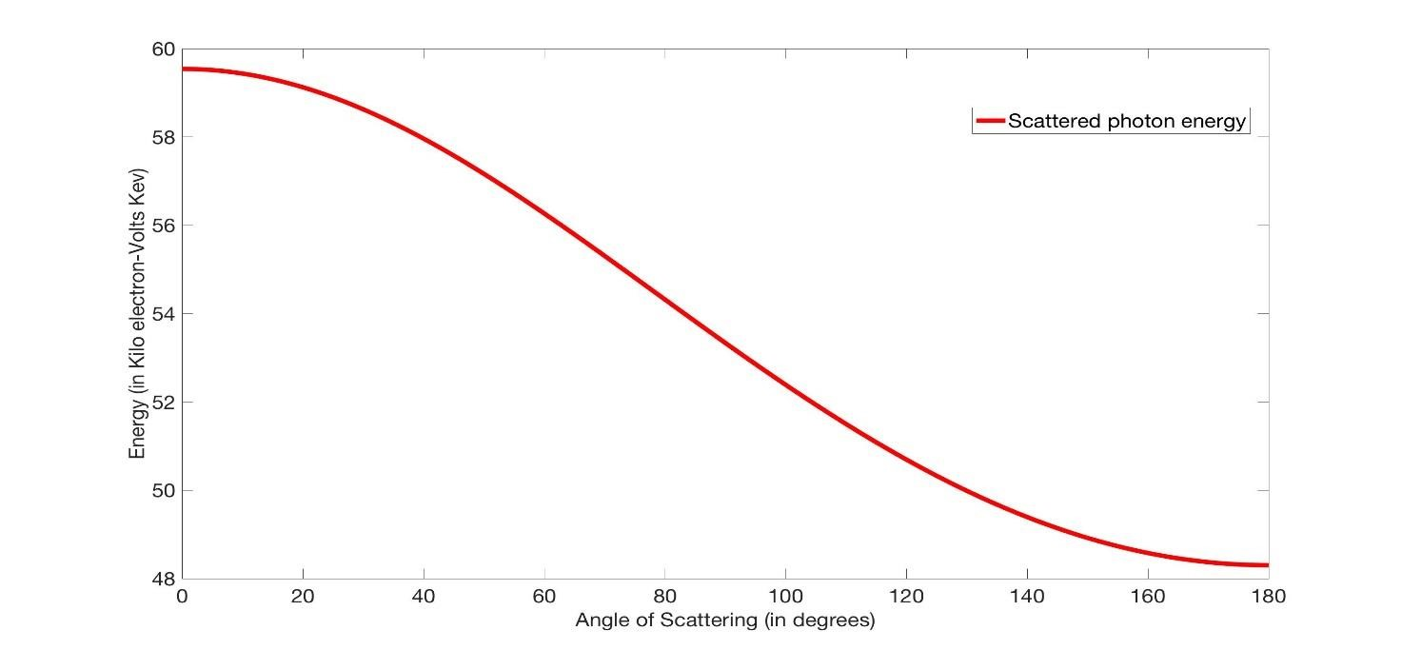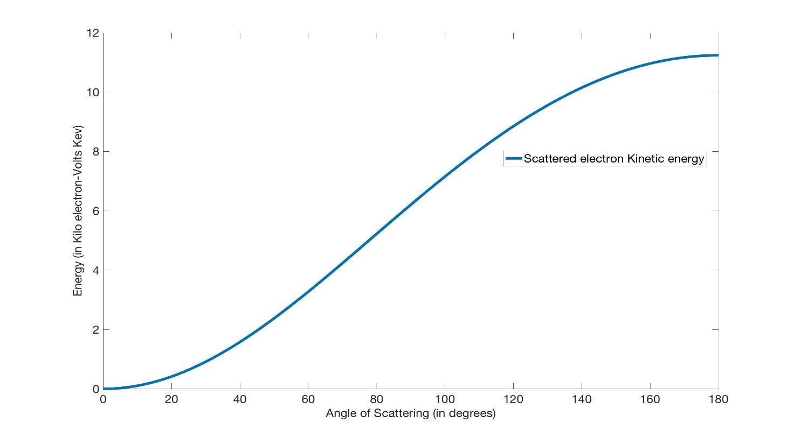

Figure 2: Scattered photon energy(top) and scattered electron energy (bottom) as a function of angle of scattering.

### Distribution functions

Two types of distribution functions are used in experimental data collection and helps us to understand how the data found.

### Normal Distribution or Gaussian distribution

If data tend to be around a middle value that means its obeying the Gaussian distribution. If the data follow the below condition then it can be said as normally distributed,

1. If mean, mode and mode are same for the data.
2. Symmetry about the center and
3. 50% of the data are greater than mean and 50% less than mean

The probability density of the normal distribution is

 (7)

And the cumulative distribution function is

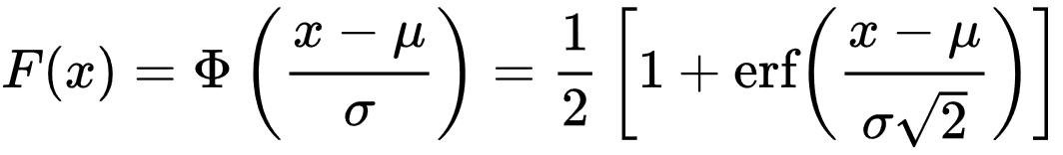 (8)

Where mean or expectation of the distribution=µ

Variance= σ2

and standard deviation=σ

[5] [6]

### Cauchy Distribution or Lorentzian distribution

In Cauchy distribution has no mean, variance or higher moments defined. Mode and median are defined very well, and they are equal to x0.

The Cauchy distribution has the probability density function of

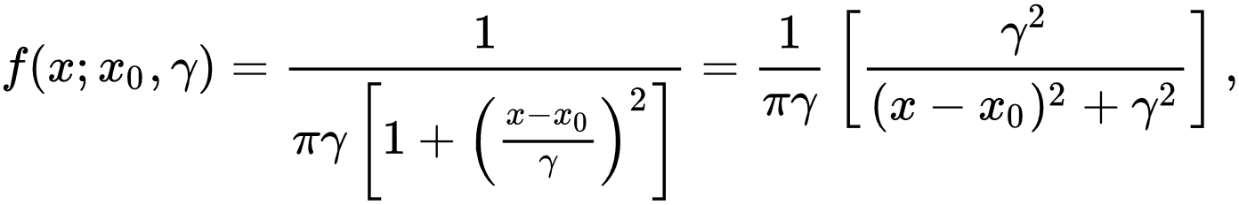 (9)

The special case when x0=0 and γ=1 is called the standard Cauchy distribution with the probability density function

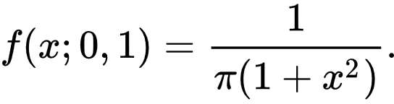 (10)

The cumulative distribution function of Lorentz distribution function is

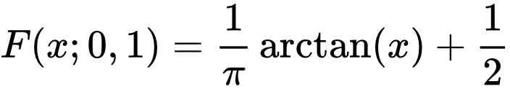 (11)

Where x0= location parameter

γ= scale parameter which specifies (HWHM) half-width at half maximum.

[7]

### Normal Distribution vs Cauchy distribution

In figure below, we compare this two with different value of parameter



Figure3: Normal distribution in different parameter

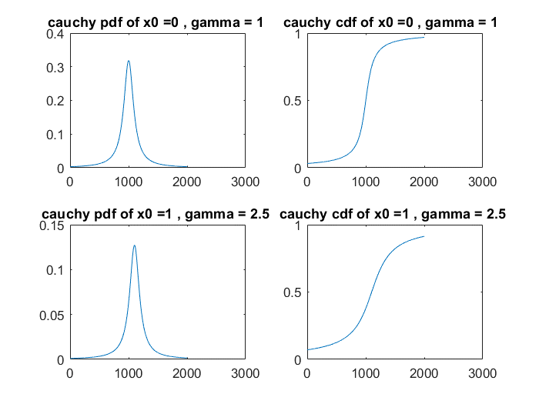

Figure4: Cauchy distribution in different parameter

#### Procedure and Experimental system

#### Experimental Apparatus

Requirement instrument for this experiment is

1. Specimen chamber (contain an angle adjustable sample of Am-241)

2. XR-100CR X-ray detector

3. Sample holder

4. Amptek PX2T/CR power supply and amplifier for the X-ray detector

5. Pocket MCA 8000A multichannel analyzer

6. AmpTek ADMCA measurement software

7.Am-241 calibration sample [8]

All this apparatus connected by following figure



Figure 5: Instrument setup. [8]

#### Operating principle

We use gamma ray spectroscopy method for studying the Compton effect. In this measurement we need to measure the gamma rays energy (photon source) before and after the collision. XR-100CR X-ray detector which is used to measure it. There are 3 primary ways that gamma rays interact with matter these are 1. Photoelectric absorption 2. Compton scattering 3, pair production. The detected gamma ray may be from radioactive source or scattering. The size of the voltage pulse and detector energy deposited in multichannel analyzer(MCA). The MCA measure all distribution voltage pulse heights or spectrum of voltage pulses. For multiple gamma rays interacting in the crystal depending on the type of interaction that occurs. After those effects are studied Compton scattering is the most probable process over the range of energies between others range. [9]

#### Effects of energy spectrum collection time in result

#### Energy calibration

MCA measures two types of data, real time (Measurement time) and live time (Spectrum collection time). Measurement time is the time for the whole duration of measurement while spectrum collection, in the other hand, is the actual duration of time for which MCA is sensitive to incoming counts. The MCA does not need a lot of time to analyze the signal, and during this analysis time, it is insensitive to any other incoming signals and would miss processing them. Therefore, it pauses the timer during the processing time. At low signal rates, there is not much difference in either of these times. It is best to use live time to accumulate data for equal times for comparison the energy calibration.

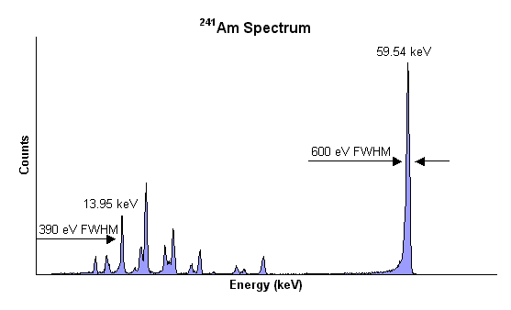

Figure 6: 241Am spectrum. [10]

As the collection time extends, the peak will be more obvious, and thus the spectrum is more readable.

# References

|  |  |
| --- | --- |
| [1] | M. P. Simon Lacoste-Julien, "Mcgill university webpage," [Online]. Available: http://msdl.cs.mcgill.ca/people/slacoste/school/modern_physics/Compton.pdf. [Accessed 5 3 2018]. |
| [2] | M. E. P. Simon R. Cherry, "ScienceDiect," [Online]. Available: https://www.sciencedirect.com/topics/medicine-and-dentistry/compton-scattering. [Accessed 5 3 2018]. |
| [3] | D. Bes, in *quantum mechanics : a modern and concise introductory course*, spinger. |
| [4] | "hyperphysics," [Online]. Available: http://hyperphysics.phy-astr.gsu.edu/hbase/quantum/imgqua/Compton2.gif. [Accessed 5 3 2018]. |
| [5] | "wikipedia," 4 3 2018. [Online]. Available: https://en.wikipedia.org/wiki/Normal_distribution. |
| [6] | "math is fun," [Online]. Available: https://www.mathsisfun.com/data/standard-normal-distribution.html. [Accessed 4 3 2018]. |
| [7] | "wikipedia," [Online]. Available: https://en.wikipedia.org/wiki/Cauchy_distribution. [Accessed 5 3 2018]. |
| [8] | "FYS-1326 Methods in Physics Project 3. Energy spectrum analysis - the compton effect," [Online]. Available: https://moodle2.tut.fi/pluginfile.php/468108/mod_resource/content/0/Compton_Instructions.pdf. [Accessed 5 3 2018]. |
| [9] | D. J. E. Parks, "compadre," [Online]. Available: http://www.compadre.org/advlabs/bfyii/files/ComptonScatteringExperimentRev3.0020150106.pdf. [Accessed 5 3 2018]. |
| [10] | "amptek," [Online]. Available: http://www.amptek.com/wp-content/uploads/2013/12/cdte_2.png. [Accessed 5 3 2018]. |